CLIMATE CHANGE

Melton Borough Council is opening the conversation with residents, businesses and community groups about climate change.

Over the next few months, the council will be running a comprehensive consultation to collect local views, starting an ongoing discussion between the council and community on this topic. A survey asking local residents, businesses and organisations for their views is available to complete from today until 30 April 2022. In addition, throughout the consultation period, the council will be holding numerous engagement events with various groups and individuals, listening to local people and understanding what they want to see happen locally.

Full details can be found on the [Melton Borough Council website](https://linkprotect.cudasvc.com/url?a=https%3a%2f%2fwww.melton.gov.uk%2fyour-council%2fnews-and-awards%2fnews%2fcouncil-seeks-views-on-climate-change%2f&c=E,1,IdFssoZa78cRuwBzL6c64vGkL8BcNUWcAXy72AgrW3pCV0utd-WTK7FLcBrYaCL5CIceDEWBk2_ZGW7HDPrHccB9LgrFldrovsgnC7BAkCzB0cASxmo5iDOag0E,&typo=1).

Many Thanks

**Catherine Murrell  
Communications Assistant**

T: 01664 502364

M: 07901 317063

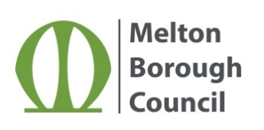

[Follow us @MeltonBC](https://twitter.com/MeltonBC)

[Visit our website for the easy way to access services 24/7](https://linkprotect.cudasvc.com/url?a=http%3a%2f%2fwww.melton.gov.uk%2f&c=E,1,8XWJs6Wm-G1tWNFfnEygzQvm94iA9xtsiXVsa_4D_rU3duMZIA5xeuVQ_DqNc33Gav8h0mdy0Q3Q2LtX02yv6UxXKpPkcrXIBvy5J8AhLNv7y2OulUPZPd9EUNg,&typo=1)

